Introduction: A30 supports capacitive proximity switch or 3D touch for automatic leveling

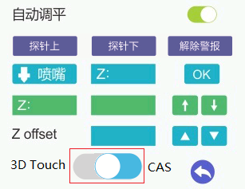

1.supports capacitive proximity switch

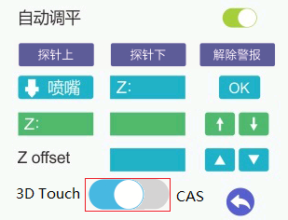

2. supports 3D touch

To achieve 3D touch support, you need to change the terminal block on the extruder to the pin header. (The circuit board itself has a 3Dtouch wiring port, but there is no soldering terminal, the user can modify it himself, it is easy)

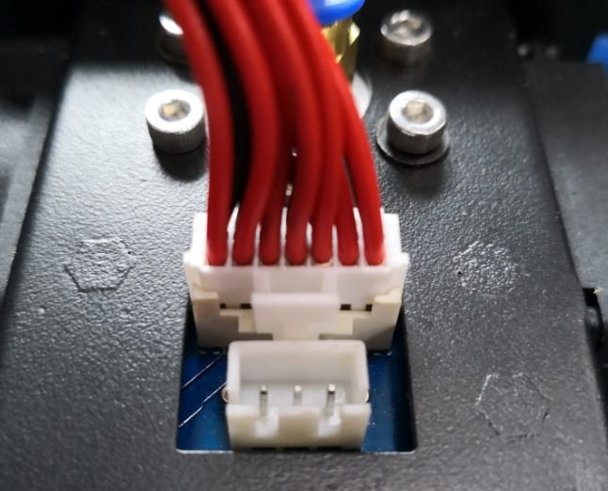

Terminals changed to pin header

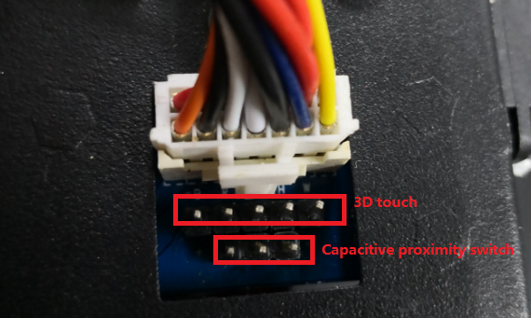

3D touch wiring

